1.    Include “Cert Type” in the Report Criteria:

We are unable to filter out by Cert Type (e.g. AK / AJ / E) and the data retrieved is for all Forms included in the shipment booking even if it is not required for that particular country. As a result, information collected is messy and a lot of sorting is required before we are able to use the report.

Current:

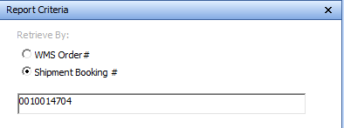

New criteria to include in report:

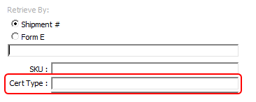

New criteria will allow retrieval by Shipment number with option to filter out by Cert Type.

2.    Add an “Item Description” Column, from SKU master, into the report.

Current:

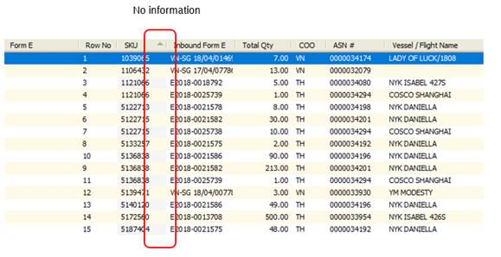

To add:

Item Description from SKU Master

